**WHAT IS BODY WASH?**

In the world of skin care, dirt, oil, and sweat are the opponent. When we have too much grime on our bodies, we tend to feel unclean, irritation on our skin make us tighten up and even anxious. Washing it off is far more soothing, feels your skin healthy and moisturize which provides your skin cells relaxation and made yourself more comfortable and enjoyable.

Before Proctor and Gamble developed Ivory Soap in 1878, cleaning yourself meant washing with a crudely made soap derived from animal fat, water and ash in the early ages . Today, cleaning yourself with bar soap isn't the only way to wash dirt and sweat off. There are several different types of popular cleansing products you can use on a daily basis to not only keep clean from head to toe, including cleansing creams, astringents and toners, abrasive scrubs, facial masks and [body wash](https://www.beautytipsforwomen.info/).

Body wash is similar to soap in the way it creates lather, but there are a few key differences that set the two apart. The reasons someone might choose a body wash over soap, for instance, have to do with skin sensitivity and personal preference because soaps are uncovered after opening and body wash remain untouched and covered while using , harsh soaps can be a little more abrasive, whereas body wash, especially formulas containing moisturizers, is gentler on the skin.

The purpose of body wash is to rid your skin of things like dirt, excess oil, odor, sweat and [makeup](https://www.beautytipsforwomen.info/makeup-tips-for-your-bridesmaids/) not only make yourself feel refreshing but also make your skin [healthy](https://www.beautytipsforwomen.info/tips-on-how-to-stay-healthy/) .

**HOW TO USE BODY WASH?**

If you use body wash, wet your skin in the shower or bath, lather some of the body wash on your hands and use a loofah or a washcloth to apply it to your skin. Rinse it off and pat dry with a towel. Don't rub, because rubbing takes away moisture , and make sure use it with warm instead of hot water, Hot water and large quantities of water can dry out your skin, so to stay soft and smooth, work on conserving water. Experts recommend that you [moisturize](https://www.beautytipsforwomen.info/5-simple-tips-to-relieve-dry-skin-fast/) after bathing to help keep the moisture that you just got from your body wash in your [skin](https://www.beautytipsforwomen.info/beauty-tips-for-women-skin/) .



Make sure of use of warm water instead of hot water.

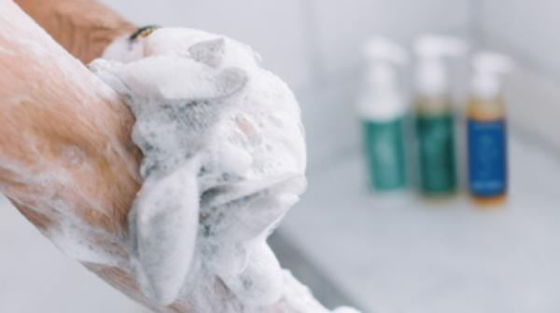

Take out the body wash as per as your body needs to be washed.

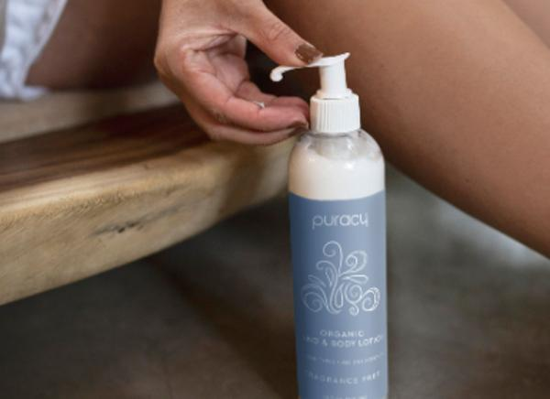

Apply moisturizer if you have already dry and rough skin to sooth your dryness.

**BENEFITS OF BODY WASH**

* When it comes to the benefit of body wash is that you get to use every last drop. You also have a lot of control over how much you squirt onto your loofah or body cloth. For that reason, body wash is typically the smarter buy.
* Body wash is more hygienic compared to the bar soap because soap is uncover and get consumes the possible germs in itself while body wash is covered with the help of container and remain untouchable.
* You can carry easily the travel sized bottle with yourself without concerning that it spilt out or create any messiness while having wet bar soap after being used by onced.
* There is some truth here. Many bar soaps on the market contain sodium lauryl sulfate, a surfactant that can strip away the body’s natural oils. Plus, they usually have a high pH - around 9-10 - while the body’s pH is usually slightly acidic, resting at around a pH of 5-6.
* Body wash not only clean the dirt and turn your sweat into refreshing fragrance but it also provide a lovely [glow](https://www.beautytipsforwomen.info/6-eastern-spices-for-glowing-skin/) and [shine](https://www.beautytipsforwomen.info/5-beauty-secrets-for-women/) to your skin.

**BEST BODY WASH FOR ALL SKIN NEEDS**

Some of the best body washes includes Nivea body wash in [Coconut oil](https://www.beautytipsforwomen.info/home-beauty-tips-use-coconut-oil/) and honey is among the many greatest physique washes accessible for ladies. It comprises Hydra DNA 24 hours moisture locking know-how that provides you silky mushy pores and skin after a shower. You’ll be able to loosen up comfortably and really feel refreshed after every bathe which you’re taking with it. The moisturizing formulation pampers the pores and skin and also you truly get to take pleasure in your tub time day-after-day. You’ll be able to purchase wholesome pores and skin by taking it every day.

Body wash might be the most misjudged excellence thing in your everyday practice, except it shouldn’t be. It’s the main item that contacts your skin and one of only a handful few things you utilize each day, in addition to it basically works as your unmistakable fragrance.

Excessively sweet or excessively flower and you can wind up resembling terrible teenager recollections, while anything in the woodsy family can decide in favor excessively perfumed. In some cases it’s about the extra-effervescent foam or cooling gel; different occasions our simply motivation to try and clean up is to alleviate dry, irritated skin. In any case, your body wash should be deserving of the Arctic excursion from bed to shower. To find out the best body was, [keep reading](https://www.beautytipsforwomen.info/top-body-washes-for-all-skincare-needs/).